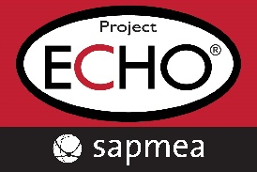
Weight Management ECHO case template
Please complete this form electronically and submit to: ECHO@sapmea.asn.au
- Not all sections of this template need to be completed or completed in detail.
- Patient identifiable information must not be included.
      - Case submissions must be your own patient.

Patient background information
Age and Gender:
Does the patient identify as Aboriginal and/or Torres Strait Islander?
Family & Social support network:
Other relevant background information:

Weight and Medical Health History
Current weight (kg):
Height (cm):
BMI:
Weight trend over past years:
Has the patient experienced significant unintentional weight change?
Relevant Medical History (e.g. T2DM, PCOS, NAFLD, sleep apnoea, osteoarthritis, CVD):
Psychosocial factors impacting weight management (e.g. stress, emotional eating, trauma, disordered eating history):

Medications:
Current medication/s

Past Medication/s

Lifestyle and Non-Pharmacological Management
Nutrition (include any dietary pattern followed or past dietary interventions):
Physical Activity (type, frequency, limitations):
Sleep:
Smoking / Alcohol use:
Engagement with allied health or other supports (e.g., dietitian, EP, psychologist):

Relevant tests/imaging: (please specify the type of test, date, and results)

Patient-defined goals of care: What is important for the patient and the family?

Other comments/information

What are your questions for the Weight Management ECHO Network? (Please list)

